1. What is React.Js ? Explain the Features of React.js

React.js is a JavaScript library used to build fast and interactive user interfaces, especially for single-page applications. It allows developers to create reusable UI components.

Features

1. Component-Based Architecture – UI is built using reusable components.
2. Virtual DOM – Improves performance by updating only changed parts of the UI.
3. One-Way Data Binding – Ensures a unidirectional data flow for better control.
4. JSX (JavaScript XML) – Allows writing UI using a syntax similar to HTML.
5. Fast Rendering – Uses a virtual DOM for efficient updates.
6. React Hooks – Enables state and lifecycle management in functional components.
7. Easy to Learn & Use – Simple and developer-friendly syntax.

2. What is difference between Actual DOM and Virtual DOM?

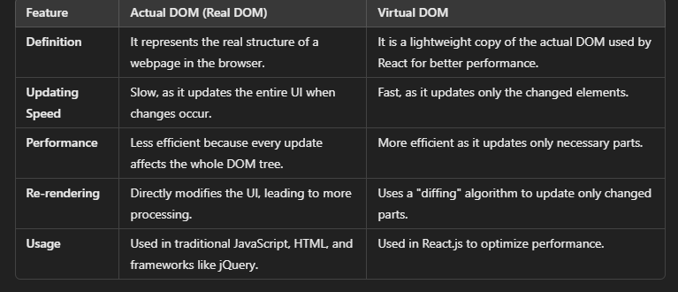

3. What is component in react?

A **component** in React is a reusable piece of UI. It helps in breaking the webpage into smaller parts. There are two types: **Functional** and **Class** components.

4. How many types of component in react? Explain class component and functional component?

### **Two Types of Components in React**

1. **Functional Component** – A simple JavaScript function that returns UI (JSX).
2. **Class Component** – A JavaScript class that extends **React.Component** and has a state.

5. Explain the life cycle of class component (Mounting , Unmounting, Updating)

React class components go through three main phases:

1. **Mounting** – When the component is created and added to the DOM.
2. **Updating** – When the component re-renders due to state or prop changes.
3. **Unmounting** – When the component is removed from the DOM.

6. How to implement life cycle phase (Mounting, Updating, Unmounting) using functional component.

import React, { useState, useEffect } from "react";

function LifeCycleComponent() {

const [count, setCount] = useState(0);

// **Mounting & Updating Phase**

useEffect(() => {

console.log("Component Mounted or Updated");

return () => {

// **Unmounting Phase**

console.log("Component Unmounted");

};

}, [count]); // Runs when 'count' changes (Updating)

return (

<div>

<h1>Count: {count}</h1>

<button onClick={() => setCount(count + 1)}>Increment</button>

</div>

);

}

export default LifeCycleComponent;

1. What do you mean by statefull and stateless component ?

### **Stateful Component:**

A **stateful component** is a React component that **manages and stores state**, allowing it to update dynamically based on user interactions, API responses, or other events. It can modify its state using the useState Hook (in functional components) or this.state (in class components).

### **Stateless Component:**

A **stateless component** is a React component that **does not have its own state** and only relies on **props** to render the UI. It receives data from a parent component and displays it without making any internal state changes.

1. What is the difference between state and props.

9. What is difference between an Element and components ?

10. What happen when we call setState method

11. Can we re-render component without using setState

12. What is eager loading and lazy loading in react?

13. How we can load the components eagrly and lazily?

14. What is error boundaries in react ?

15. How to implement routing in react? What is use of BrowserRouter and Routes

16. What is props driling in react?

17. What is pure component in react ? How create pure class component?

18. How to use function component as pure component?

19. What is Higher order component(HOC)

20. What is protected/private route in react.js

21.What are react fragements?

22. What are the hooks in react.js ? Explain some hooks which used in your project?

23. Explain following

a. useState

b. UseLocation

c. useNavigate

d. useRef

e. UseMemo

f. UseCallback

g. UseDispatch

h. UseContext

i. useSelector

j. UseEffect

24. in which life cycle method you would like to make a http call

25. Where to make a api/http/network call in functional components

26. Write a code using useEffect to implement mounting, updating and unmounting in functional components.

27. Can we update props ?

28. How to upate parent state data from child component ?

29. What is context api in react.js

30. What is reducx? Explain the component of react (Store, Action, Reducer)?

31. What is difference between useState and useReducer

32. What is call, bind, apply in js

33. Difference between context api and redux?

34. What is RTK ?

35. what is the use async thunk (createAsyncThunk) ?

36. What is memo in reactjs

37. What is JSX ?

38. What is reconciliation ?

39. What is controlled component and uncontrolled components ?

40. What does shouldComponentUpdate do and why is it important?

41. Describe how events are handled in React.

42. What is the second argument that can optionally be passed to

setState and what is its purpose?

43. List down the variation of setState() in reactjs ?

44. what is props.childrens ?

45. Does react use HTML ?

46. Tell me most signification drawback of reactjs?

47. Explaing React Router?

48. How modify each request and response (Interceptor) in react.js

49. What is rest api ? How to call api from react ?

50. How to send file in request from react ?

51. Why should we not update the state directly ?

52. What is the purpose of callback function as an argument of setState()

53. How to bind method and event handlers in jsx ?

54. What are syntheic event in reactjs ?

55. What are inline conditional expression ?

56. What is key props and what is the benefit of using it in arrays of elements?

57. What is the use refs ?

58. How to create refs?

59. What are forward ref ?